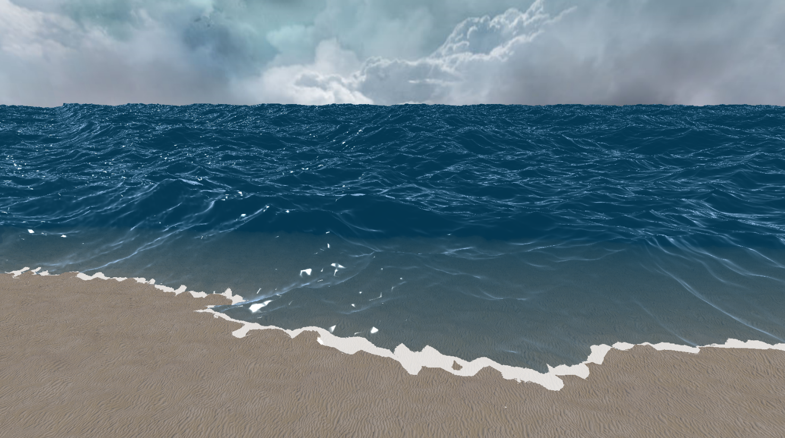

Technical Design Document

**Large Scale Ocean Rendering and Simulation**

Version 1.0

|  |  |  |
| --- | --- | --- |
| **Position Title** | **Name** | **Signature** |
| Programmer | *Spencer McKean* |  |
| Advisor | *Matt Butler* |  |

Table of Contents

Table of Figures 3

Table of Equations 4

Table of Tables 5

Introduction 6

Overview 6

Scope 6

End Product 7

Theory 8

Navier-Stokes Equation 8

Dispersion Relation 8

Gerstner Waves 9

Fourier Transform 9

Jacobian Matrix 11

iWave 13

Implementation 15

Gerstner Waves 15

Discrete Fourier Transform 15

Fast Fourier Transform 15

Reflections and Refractions 18

Depth 20

iWave 22

Water Objects 23

Bibliography 24

# Table of Figures

Figure 1: Non-choppy water (λ = 0) 11

Figure 2: Choppy water ( λ = -1) 11

Figure 3:Wave height profile with and without the displacement. 12

Figure 4: iWave convergence. Dashed lines at P=6 14

Figure 5: Butterfly Algorithm 17

Figure 6: Reflection, Refraction, and Transmission [4] 18

Figure 7: Fresnel 19

Figure 8: Specular highlighting 19

Figure 9: Refraction map 20

Figure 10: Underwater depth fade 21

Figure 11: Surface depth fade and foam 21

Figure 12: iWave in action. Ripples caused by sources and the crate is an obstruction. 22

Figure 13: Bobbing water object 23

# 

# Table of Equations

Equation 1: Navier-Stokes Equation [1] 8

Equation 2: Bernoulli's Equation [2] 8

Equation 3: Nonlinear Navier-Stokes Equation [2] 8

Equation 4: Dispersion relation equation [2] 8

Equation 5: Gerstner Wave Equations [2] 9

Equation 6: Gerstner Wave magnitude [2] 9

Equation 7: Full Gerstner Wave equations [2] 9

Equation 8: Fourier Transform form for wave fields [2] 9

Equation 9: Fourier amplitudes at time [2] 10

Equation 10: Fourier amplitudes [2] 10

Equation 11: Phillips Spectrum [2] 10

Equation 12: Fourier form displacements [2] 10

Equation 13: Fourier form surface normals [2] 11

Equation 14: Jacobian matrix equations [2] 12

Equation 15: Kernel scaling value [3] 13

Equation 16: Kernel element [3] 13

Equation 17: Vertical Derivative at position within kernel [3] 14

Equation 18: iWave propagation [3] 14

Equation 19: Twiddle factor for FFT 16

Equation 20: Single stage FFT computation 17

Equation 21: Reflectance for Fresnel [2] 18

Equation 22: Computing the Fresnel of the water's surface 18

# Table of Tables

Table 1: Twiddle factor computations 16

# Introduction

Inspired by the game Sea of Thieves, created by Rare, the idea of this project was to recreate the ocean surface simulation achieved in that game. Using the Fast Fourier Transform (FFT) the project achieves a realistic simulation of the ocean’s surface that runs at interactive speeds even on a large scale. This coupled with an additional simulation method called the iWave method allows objects to move across the surface creating ripples and wakes as well as react to variable ocean floor depths. To discover exactly what performance implications these formulas and methods have profiling data was collected for different wave settings.

# Overview

*In exploration of different wave generation methods used throughout the gaming industry, this thesis sets out to achieve the most realistic wave simulation possible for games. Using statistical models, this FFT method generates waves that behave realistically with finer detail then other methods. In the industry the simple solution for water surface simulation is Gerstner Waves. This methods aims to alleviate issues found within that method. In addition to vertex manipulation the appearance of the water’s surface is also important thus part of the exploration involves the pursuit of effective water rendering techniques.*

## Scope

*The goal of this project is to simulate the ocean’s surface as realistically possible while maintaining performance. This involves getting familiar with common practices and the easier forms of wave generation. The next step is to become more comfortable with the way in which to apply the Fourier Transform to the mesh vertices as effectively as possible. Once the mesh is generated the focus can shift to making the manipulation of the vertices performant, requiring the use of the FFT. After this the goal is to tackle the refraction and reflection and its effect on the visuals looking at and through the water’s surface. This leads to a need for terrain and back buffer manipulation. Once this is accomplished, the goal can then become to implement interactive waves using the iWave method.*

## End Product

*Gameplay*

* *Flying, no-clip, scene camera*
* *Wave Simulation and scene control hot key access*

*Game Objects*

* *Ocean Surface*
* *Terrain*
* *Interactive Water Objects*

*HUD & UI*

* *Runtime benchmark averages*
  + *Total Update time*
  + *FFT Time*
  + *FPS*
  + *Render Time*
* *Current Simulation Values*
  + *Wind Speed*
  + *Wind Direction*
  + *Global Wave Amplitude*
  + *Wave Suppression Value*
  + *Tiled Size*
  + *Choppiness Value*
  + *Surface Dimensions*
  + *Surface Vertex Dimensions*

# Theory

### Navier-Stokes Equation

The Navier-Stokes equations determines the motion of a fluid based on velocity u(x,t), pressure p(x,t), force F(x,t), and density [1]. Where x is the position of the fluid and t is time.

$$\frac{∂u}{∂t}+u∙∇u=-∇p+F$$

$$∇∙u\left(x,t\right)=0$$

Equation : Navier-Stokes Equation [1]

#### Bernoulli’s Equation

Bernoulli’s Equation takes the Navier-Stokes equation and simplifies the complex nature of the equation to only give the velocity one degree of freedom instead of three [2]. Where velocity u is converted into potential flow ɸ.

$$u\left(x,t\right)= ∇ɸ(x,t)$$

Equation : Bernoulli's Equation [2]

This allows the Navier-Stokes Equation to become a fully nonlinear equation. Where U(x,t) is some potential energy function [2].

$$\frac{∂ɸ}{∂t}+\frac{1}{2}{(∇ɸ)}^{2}=-p-U$$

Equation : Nonlinear Navier-Stokes Equation [2]

#### Linearization

To achieve interactive speeds for the simulation Bernoulli’s equation needs to be further simplified to linearize the equations of motion and restrict the evaluation to only the points on the surface of the fluid.

### Dispersion Relation

The Navier-Stokes Equation, simplified and with approximated values can be expressed in a single equation imposing the constraint that the temporal frequency ω of surface height movements is connected to the spatial extent of the propagating wave k = |k|.

Equation : Dispersion relation equation [2]

### Gerstner Waves

A simple implementation for modeling the surface of the ocean as a wave passes over a point. A good approximation of any point on the surface of an ocean reacting to a wave is in a circular motion [2]. This means that the equations boil down to simple sin and cos equations.

$$x = x_{0} - (\overset{⃑}{k}/k)A sin(\overset{⃑}{k} · x_{0} - ωt)$$

$$z= A cos(\overset{⃑}{k} · x_{0} - ωt)$$

Equation : Gerstner Wave Equations [2]

Where x is the point on the horizontal plane, x(x,y), and the height of the surface at that point is z. Where k is the magnitude of the wave, A is the amplitude of the wave, and the length of the wave is λ.

$$k=\frac{2π}{λ}$$

Equation : Gerstner Wave magnitude [2]

This equation for a single sin wave can be incorporated into a summation that allows for the modeling of a more complex wave pattern. Where ɸ is the wave’s phase.

$$x = x_{0} - \sum_{i=1}^{N}{({\overset{⃑}{k}}_{i}/k_{i})A_{i} sin({\overset{⃑}{k}}_{i} · x_{0} - ω_{i}t + ɸ_{i})}$$

$$y = \sum_{i=1}^{N}{A_{i} cos({\overset{⃑}{k}}_{i} · x_{0} - ω_{i}t + ɸ_{i})}$$

Equation : Full Gerstner Wave equations [2]

### Fourier Transform

$$h\left(\overset{⃑}{x},t\right)=\sum_{\overset{⃑}{k}}{\tilde{h}(\overset{⃑}{k},t)}e^{i\overset{⃑}{k}∙\overset{⃑}{x}}$$

Equation : Fourier Transform form for wave fields [2]

The Fourier Equation used on a wave vector field to determine the height of the waves at time, $t$, for the point $x$. For the summation of all wave vectors, $k$, described in the form of $k(k_{x}, k_{z})$. Where $k_{x}=2πn/L_{x}$ and $k_{y}=2πm/L_{y}$. Where $L_{x}$ and $L_{y}$ are the dimensions of the water’s surface in the respective direction, and where $n$ and $m$ are the index of the vertex in the x and y direction respectively. To have sinusoidal behavior in the waves $n$ and $m$ are defined as such: $-\frac{N}{2}<n< \frac{N}{2}$ and $-\frac{M}{2}<m< \frac{M}{2}$, where N is the total number of samples in the x direction and M is the total number of samples in the y direction. $x$ is the position of the point in space and defined $x=(\frac{nL_{x}}{N}, \frac{mL_{y}}{M})$.

#### Fourier Amplitudes at Time

$$\tilde{h}\left(\overset{⃑}{k},t\right)= {\tilde{h}}_{0}\left(\overset{⃑}{k}\right)e^{iω\left(k\right)t}+{\tilde{h}}_{0}^{*}(-\overset{⃑}{k})e^{-iω\left(k\right)t}$$

Equation : Fourier amplitudes at time [2]

To find the Fourier amplitudes at time, the equation above is used. ${\tilde{h}}_{0}\left(\overset{⃑}{k}\right)$ is the precomputed Fourier amplitude for the vector $\overset{⃑}{k}$. ${\tilde{h}}_{0}^{*}(-\overset{⃑}{k})$ is the conjugate of that value and allows waves to propagate to the left and right. $ω\left(k\right)$ is the dispersion relation for the vector $\overset{⃑}{k}$.

#### Fourier Amplitudes

$${\tilde{h}}_{0}(\overset{⃑}{k})=\frac{1}{\sqrt{2}}\left(ξ_{r}+{iξ}_{i}\right)\sqrt{P_{h}(\overset{⃑}{k})}$$

Equation : Fourier amplitudes [2]

The Fourier amplitudes at the vector $\overset{⃑}{k}$ can be described with this equation where $ξ_{r}+{iξ}_{i}$ is a random complex number. A good value for this number is a Gaussian distributed random number as waves tend to follow along with the numbers produced. However, other forms of random numbers can be used. $P_{h}(\overset{⃑}{k})$ is the Phillips spectrum for the vector $\overset{⃑}{k}$.

#### Phillips Spectrum

$$P_{h}(\overset{⃑}{k}) = A\frac{e^{-1/{(kL)}^{2}}}{k^{4}}{\left|\hat{k}∙\hat{ω}\right|}^{2}$$

Equation : Phillips Spectrum [2]

The Phillips Spectrum is a good model for wind driven waves that are fairly large in an ocean like environment. This equation accounts for wind in the term $L$ and $L=\frac{V^{2}}{g}$ where $V$ is the wind’s speed and $g$ is the gravitational constant. $\hat{ω}$ is the direction of the wind. $A$ is a term used to represent the global wave amplitude. In order to suppress bad values below a certain threshold a multiplicative modifier can be added to this equation.

#### Displacement and Surface Normals

In addition to using the FFT to compute the height of the simulation, the FFT can be utilized in computing the displacement of the water at a vertex based on the Fourier Amplitudes, as well as the surface normals at a vertex based on those same Fourier Amplitudes. Here are the Fourier Equations for each, $D(\overset{⃑}{x},t)$ being the displacement function and $N(\overset{⃑}{x},t)$ being the normals function:

$$D\left(\overset{⃑}{x},t\right)=\sum_{\overset{⃑}{k}}{-i\frac{\overset{⃑}{k}}{\left\|k\right\|}\tilde{h}(\overset{⃑}{k},t)}e^{i\overset{⃑}{k}∙\overset{⃑}{x}}$$

Equation : Fourier form displacements [2]

$$N\left(\overset{⃑}{x},t\right)=\sum_{\overset{⃑}{k}}{i\overset{⃑}{k}*\tilde{h}(\overset{⃑}{k},t)}e^{i\overset{⃑}{k}∙\overset{⃑}{x}}$$

Equation : Fourier form surface normals [2]

The final position of a vertex $x$ can be computed as such, $x + λD(x,t)$, where λ is a choppiness modifier.

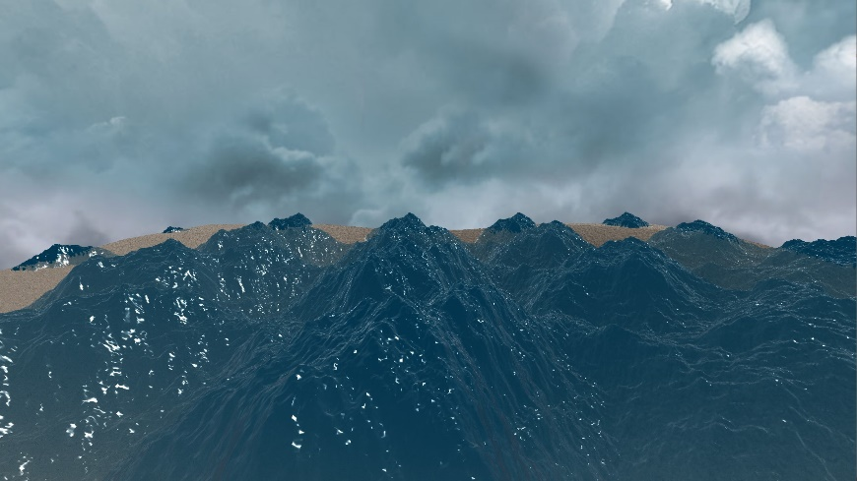

Figure : Non-choppy water (λ = 0)

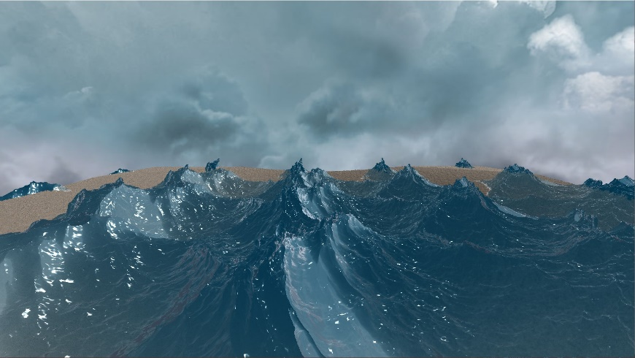

Figure : Choppy water ( λ = -1)

### Jacobian Matrix

Can be used to measure the uniqueness of the wave displacement on the horizontal plane. A set of derivatives of the displacement equation along each axis with respect to each other axis a value can be computed to indicate where waves overlap or peak. When there is no displacement the value equates to 1 and as the waves start to overlap and become less unique, the value decreases towards 0. At 0 the points are displaced into each other. Any value lower than 0 indicates that the wave has started to loop back in on itself. The Jacobian value is defined as such:

$$J\left(x\right)=J_{xx}J_{yy - }J_{xy}J_{yx}$$

$$J_{xx}(x)=1+λ\frac{∂D_{x}(x)}{D_{x}}$$

$$J_{yy}(x)=1+λ\frac{∂D_{y}(x)}{D_{y}}$$

$$J_{yx}(x)=λ\frac{∂D_{y}(x)}{D_{x}}$$

$$J_{xy}(x)=λ\frac{∂D_{x}(x)}{D_{y}}$$

Equation : Jacobian matrix equations [2]

The Jacobian Matrix is a good tool to use in finding where to create a foaming effect or cause spray with a particle system. It can also be used to show less dense water and modify the lighting appropriately. If the Jacobian value is negative it could also be used to displace the overlapping vertices out of each other.

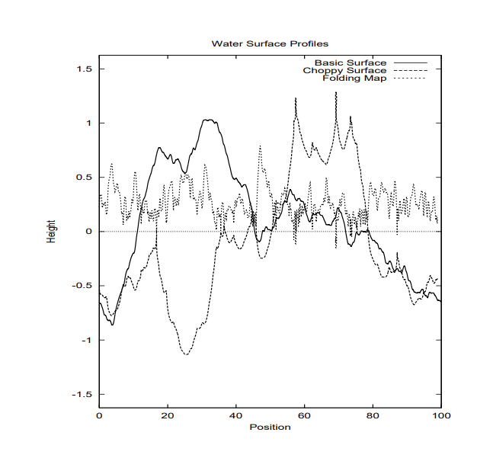

Figure :Wave height profile with and without the displacement.

Jacobian is folding map [2].

### iWave

The iWave method is designed to simulate minor changes in an already simulated ocean surface. Its goal is to create interactive waves. This means that it accounts for objects in the water and objects added to the water via sources. By performing a convolution over a small portion of the simulation’s grid iteratively over the entire simulations grid. This small portion is called a kernel. The ideal kernel size for this method is that of +6 and -6 around the center point both vertically and horizontally. Reducing the kernel size can increase performance time but reduce realism.

Once the kernel size has been established the values for the convolutions within the kernel can be calculated. These convolution values are what causes the convergence of waves back to 0.

$$G_{0}=\sum_{n}{q_{n}^{2}e^{-σq_{n}^{2}}}$$

Equation : Kernel scaling value [3]

Where $q_{n}=n∆q$ and $∆q=0.001$, a value chosen for good accuracy. $n=1,…,10000$ and $σ=1$ also chosen for good accuracy and realism. This equation used in conjunction with the following equation will cause heights with in the kernel converge down from 1 to 0.

$$G\left(k,l\right)= \sum_{n}{q_{n}^{2}}e^{-σq_{n}^{2}}J_{0}(q_{n}r)/G_{0}$$

Equation : Kernel element [3]

For each point in the square kernel with dimensions $k and l=2P+1$ where P is the kernel size. For the function $r$ is a function of $k$ and $l$ in that $r =\sqrt{k^{2}+l^{2}}$, the distance the grid point is from the center of the kernel. $J_{0}\left(x\right)$ is a Bessel function. This is what gives the equation its convergence properties. As $x$ approaches 0 the function diverges. Bessel functions are available in the standard C library.

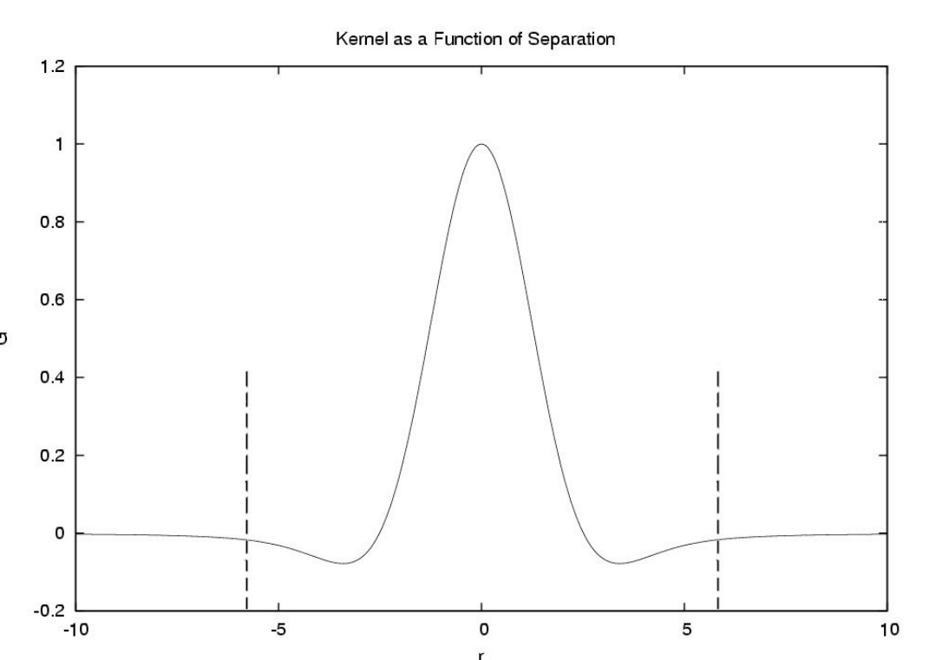

Figure : iWave convergence. Dashed lines at P=6

Once the kernel is computed we can apply it to the wave heights performing the convolution using this equation for the height at the grid points $i$ and $j$ at time, $t$: $h(i,j, t)$.

$$V\left(i,j,t\right)=\sum_{k=-P}^{P}{\sum_{l=-P}^{P}{G\left(k,l\right)h(i+k,j+l, t)}}$$

Equation : Vertical Derivative at position within kernel [3]

This equation will result in the convoluted vertical derivative at the point $(i,j)$. Once it is determined how the height will change, in having the vertical derivative, the next step is to propagate the wave height out to the surrounding vertices. This can be done via the following equation:

$$h\left(i,j, t+∆t\right)=h\left(i,j,t\right)\frac{2-α∆t}{1+α∆t}-h\left(i, j, t-∆t\right)\frac{1}{1+α∆t}-\frac{g{∆t}^{2}}{1+α∆t}V(i,j,t)$$

Equation : iWave propagation [3]

Where α is how fast the values will converge and $g$ is gravitation acceleration.

# Implementation

### Gerstner Waves

The Gerstner wave model has been used for a long time in games and is a simple approach to solving the problem of producing realistic waves. Waves follow a sinusoidal pattern and this method demonstrates that characteristic. However, there are a few draw backs to this methods, the first of which is that for every point, on update, needs to calculate each wave’s height at that time and add them together. The other drawback is that when values get too high, the waves start to fold in on themselves. Both of these in conjunction make it difficult to produce a complex wave surface.

Due to the simplicity of this model it is very easy to get working in code. To get a good grasp of what it takes to manipulate vertices on a mesh in relation to equations and to gain a better understanding what kind of effect waves have on the mesh, an implementation of this method is very beneficial.

### Discrete Fourier Transform

The Discrete Fourier Transform (DFT) is a naïve approach to solving the Fourier problem. To get the height of the water’s surface at any given point the Fourier Amplitude must be calculated for every wave vector and added to the total resulting in the height at that point. This is to determine the height that each wave as on the other waves in the system. This happens for every point and results in a complexity of $O(n^{2})$.

Taking this approach before trying the FFT allows for architecture to be put in place to calculate the values necessary as well as gain a better understanding of what the goal of the Fourier Transform is. Since the equations are the same for both FFT and DFT problems can be debugged easier with the straight forward approach in the DFT.

### Fast Fourier Transform

Using the Cooley–Tukey to perform the Fast Fourier Transform (FFT) calculations, faster speeds are achieved than what is possible with the DFT. The time complexity goes from $O(n^{2})$ to $O( n log(n) )$, where $n$ is the number of wave vectors in the system. Another name that this algorithm has is the Butterfly Algorithm. This name comes from the shape that is created when depicting what the calculations do.

#### Twiddle Factor

The twiddle factor is the result of the symmetry that resides in the Fourier Transform. What makes the FFT faster than the DFT is the symmetry and thus the twiddle factor. For any Fourier Transform equation the twiddle factor can be calculated as such where $N$ is the number of samples at that depth in the FFT algorithm and $x$ is the order in which the operation is performed at that depth:

$$T_{N}^{x}=e^{\frac{i2πx}{N}}$$

Equation : Twiddle factor for FFT

|  |  |  |  |
| --- | --- | --- | --- |
|  |  |  |  |
|  |  |  |  |
|  |  |  |  |
|  |  |  |  |
|  |  |  |  |
|  |  |  |  |
|  |  |  |  |
|  |  |  |  |
|  |  |  |  |

Table : Twiddle factor computations

#### The “butterfly” structure of the modified algorithm. On the figure +/-... | Download Scientific DiagramButterfly Algorithm

Figure : Butterfly Algorithm

In the Butterfly algorithm the sample array is recursively divided in half along the even indices resulting in a bit-reversed order. For example, [0,1,2,3,4,5,6,7] becomes [0,4,2,6,1,5,3,7]. The value at the even index, $x_{0}$, and the value at the odd index, $x_{1}$ are then modified by the twiddle factor. Once we have the correct twiddle factor for the crossing we can determine the new values as:

$$x_{0}=x_{0}+twiddle$$

$$x_{1}=x_{0}-twiddle.$$

Equation : Single stage FFT computation

To save on operations the twiddle factor can be precomputed if the size of the data set is known ahead of time. These operations happen over $N$ sample $log⁡(N)$ times. However, this requires that $N=2^{n}$.

This FFT implementation can be used for the heights, slopes, and displacement Fourier Equations. When performing the FFT in two dimensions all of the horizontally aligned vertices must be computed and then all of the vertically aligned vertices or the other way around. If this is not done the sinusoidal behavior of the waves could be lost.

### Reflections and Refractions

Simple reflections for a static scene with minimal geometry was easily accomplished by reflecting the view direction on pixel around the surface normal at that point and sampling into a cube map texture. However as the scene becomes more complex this method will no longer suffice and would require more in-depth solution to solve it.

Refractions suffer from the same issues that reflections do in that to get more realistic samples a more in-depth method would be required. With refractions the issue is not get what color to sample it is that realistic refractions have the possibility of bringing geometry that is out of the view frustum into view. However, there is a simple solution for this in perturbing the sample position based on the refractive surface’s normal resulting in a good refraction effect without having to worry about going out of bounds of the sample texture’s bounds.

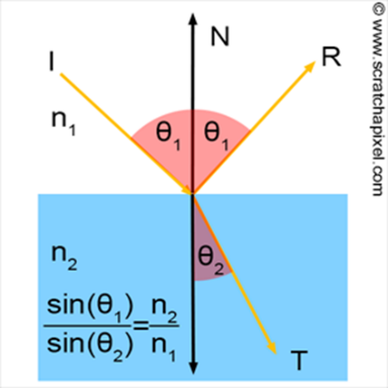

Figure : Reflection, Refraction, and Transmission [4]

Once we have the colors of the perceived reflections and refractions we can combine them to get the actual color at the water’s surface. Since no light can be lost in the system we know that the amount of reflected and refracted light equates to $Reflectance+Transmission=1$. Based on the electromagnetic theory of dielectrics we can determine the reflectance of water with the equation:

$$Reflectance=\frac{1}{2}\left\{\frac{\sin^{2}(θ_{t}-θ_{i})}{\sin^{2}(θ_{t}+θ_{i})}+\frac{\tan^{2}(θ_{t}-θ_{i})}{\tan^{2}(θ_{t}+θ_{i})}\right\}$$

Equation : Reflectance for Fresnel [2]

Where $θ_{i}$ is the angle of incidence and $θ_{t}$ is the angle of transmission. Once we have $Reflectance$ we can compute for $Transmission$ and the percent of light contribution each has. With this fraction we can compute the perceived color of the water’s surface as:

$$Reflected Contribution=Reflectance*Skybox Sample Color$$

$$Refracted Contribution=Transmission*Refracted Sample Color$$

$$Water Surface Color=Reflected Contribution+Refracted Contribution$$

Equation : Computing the Fresnel of the water's surface

In addition to this a simple specular lighting calculation can be done with the water surface normals to add bright spots from lighting resulting in a final water color of:

Figure : Fresnel

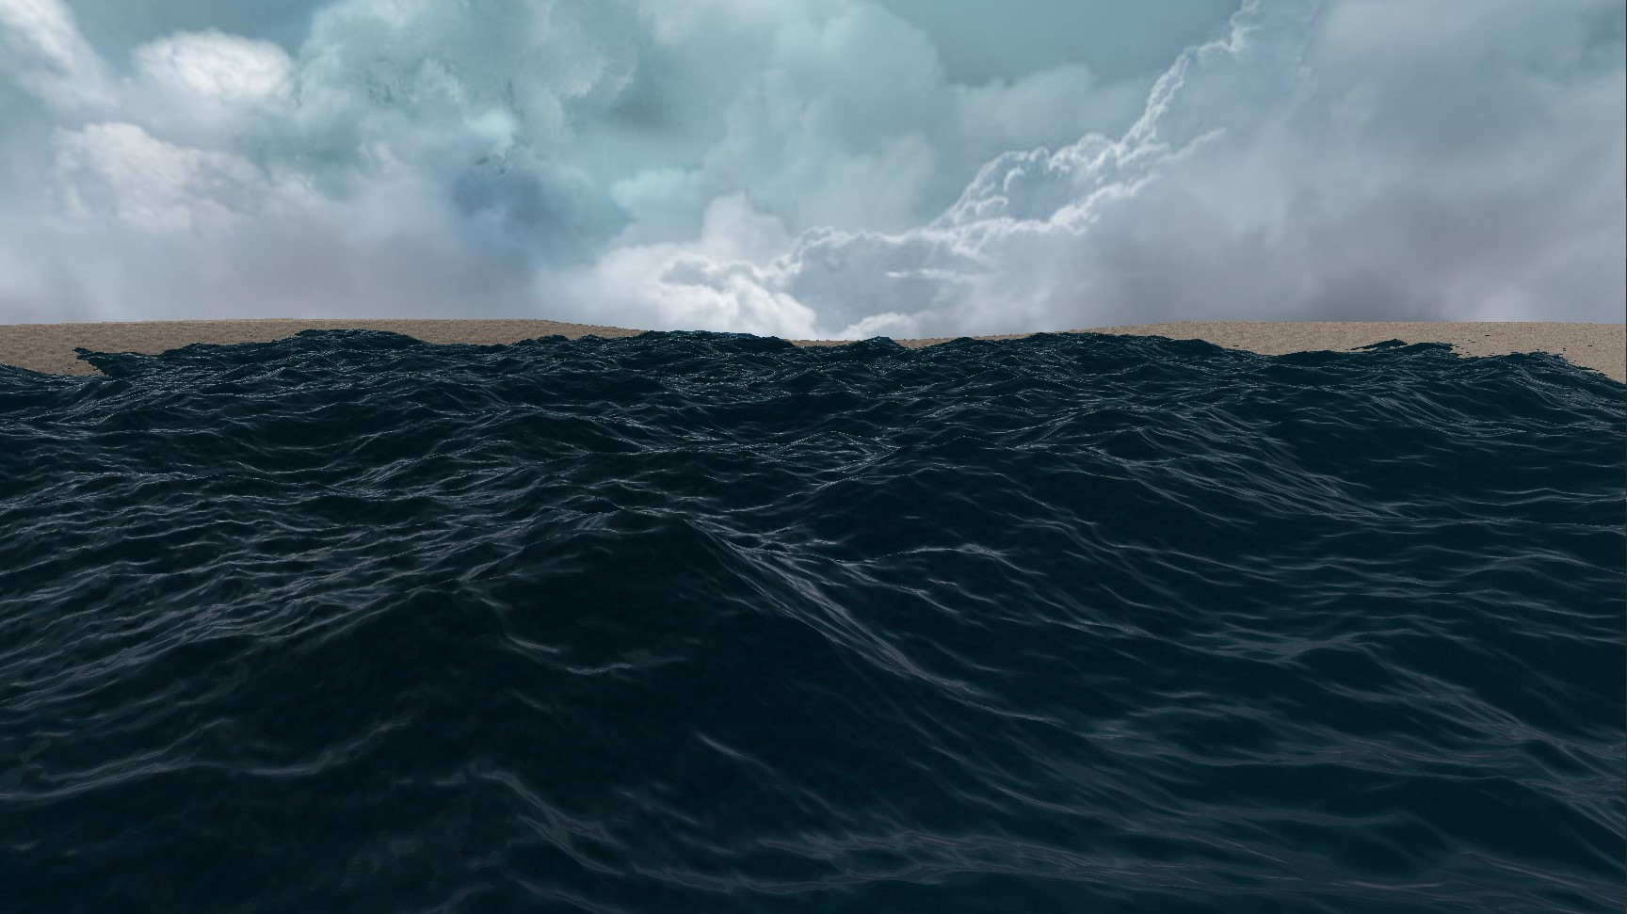

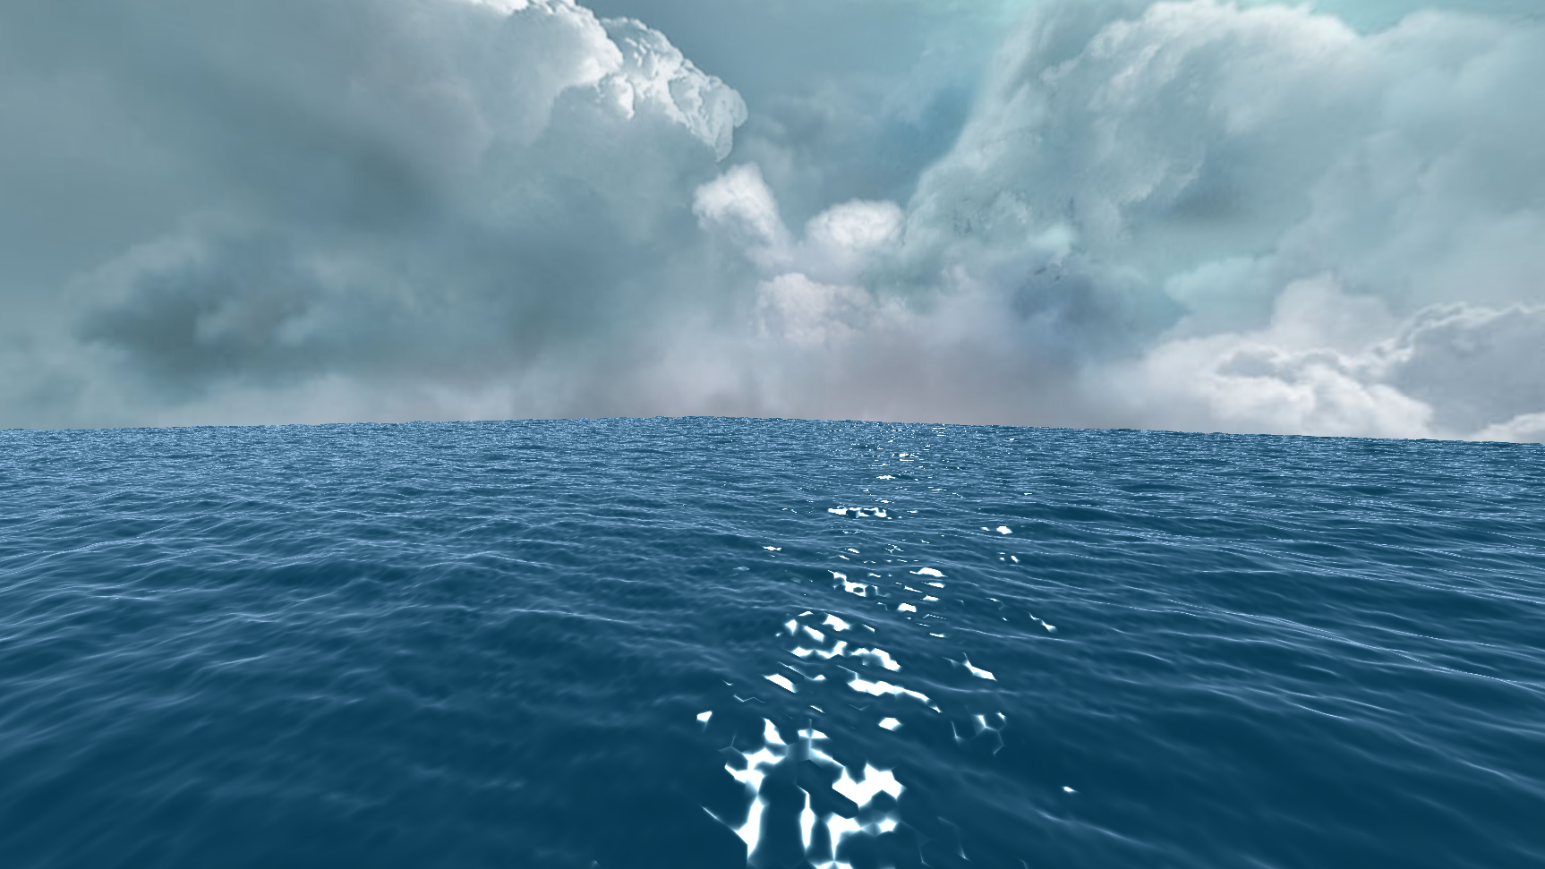

Figure : Specular highlighting

#### Refraction Map

To avoid having refraction sampling of things on the viewed side of the ocean’s surface a refraction map was used. This was created in an initial render pass of all of the objects in the scene. Refractive objects were drawn as black and the non-refractive objects were drawn as white. When doing the final pass for the refractive surfaces, in this case the water, the pixel in the refraction map at the intended refraction pixel can be black or white. If it is black that means the sample is behind the refractive surface and nothing further needs to be done. However, if the sampled pixel was white that would mean that the refracted pixel is in front of the refractive surface and should not be refracted. In this case, a good solution is to just undo the refraction.

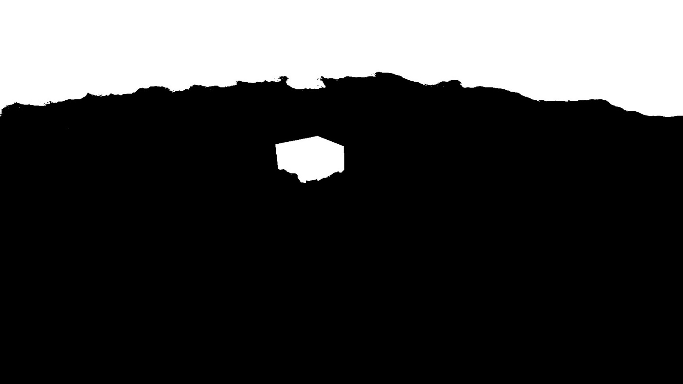

Figure : Refraction map

### Depth

Capturing the depth stencil before rendering the water allows for many interesting effects to be implemented. We can create a depth fade to a deeper water color based on what the depth stencil depth is at the same pixel we are trying to render to with the water. This can also be used to create a similar effect across the whole screen when under the water. The depth can also be used the other way too. When the water is shallow enough we can change the water color to create a foaming effect.

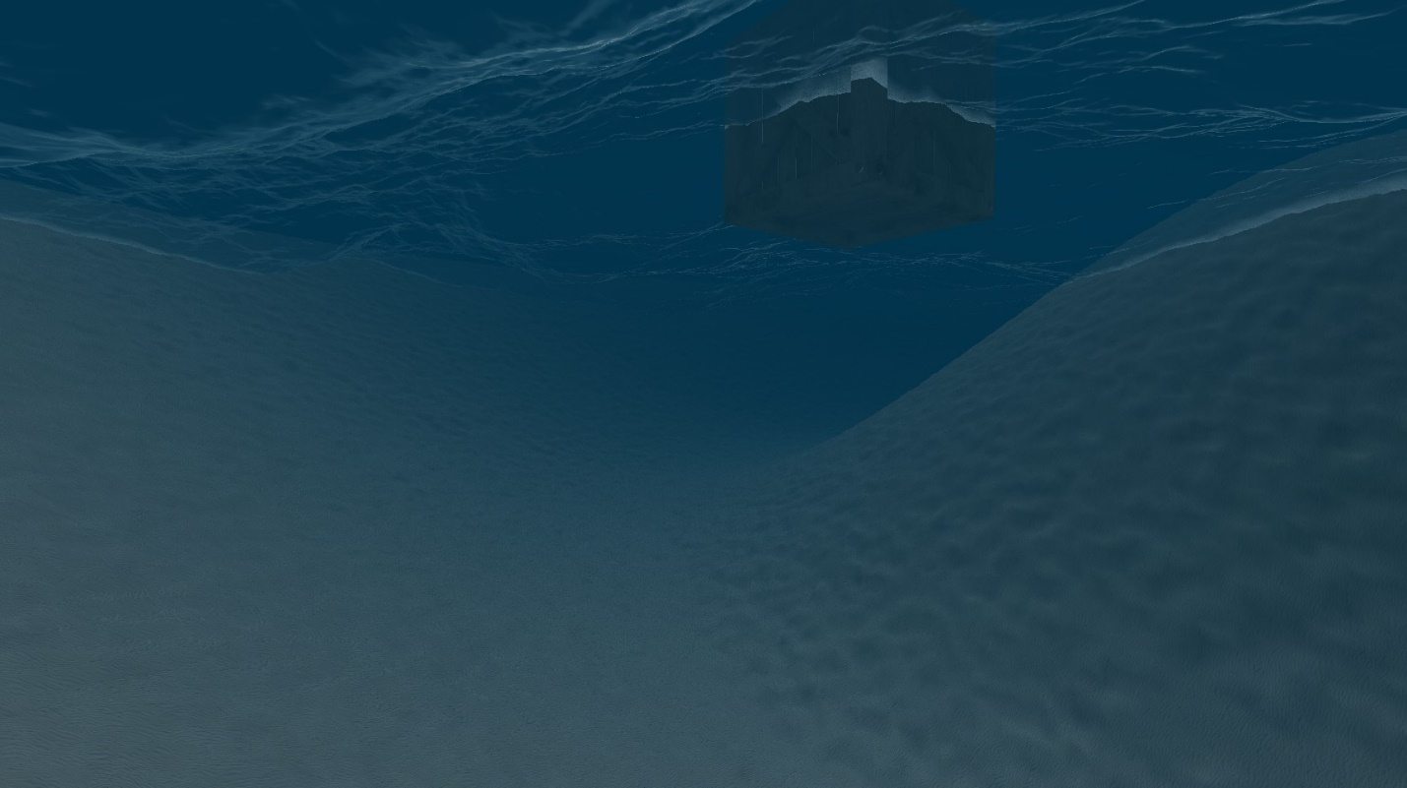

Figure : Underwater depth fade

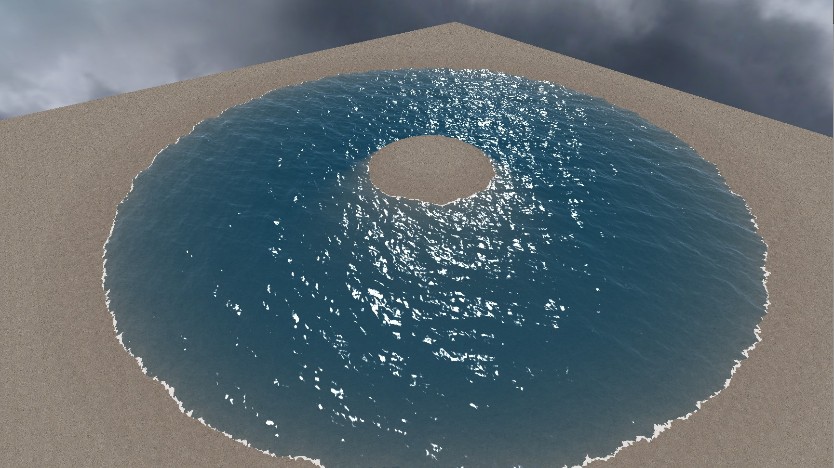

Figure : Surface depth fade and foam

### iWave

The implementation for iWave is as straight forward as the equations described above. Storing previous heights and only ever computing the current height will help to improve performance. On top of the propagation logic the iWave method is most useful in appropriately reacting to objects and sources within the water, as well as effectively layering itself on top of other simulations like the FFT one. Before doing any of the convolutions and propagation the current height can be modified based on the sources and obstructions. Being stored in their individual arrays, the same size as the simulation, sources are set to a value during a frame and then cleared at the end of the frame, and obstructions are persistent. The sources are a pure additive factor to the simulated heights at the respective grid points. This means that the values can be anything. Sources can be thought of as a pull on the surface at that point to the specified height. On the other hand obstructions are persistent values that indicate where objects or land masses are in the water. The values in the obstruction array are 1’s for open area and 0s for where there is an obstruction. Where the values are between 1 and 0 means that the obstruction does not fully contain the point. Obstructions are a multiplicative factor on the current height of the simulation at the respective grid point. By setting the values this way ripples that run into obstructions will reflect off of them.

Layering the iWave method on top of other simulations is also very simple. Where there are no obstructions simply let the non-iWave simulated height wash over the iWave height by subtracting from it the non-iWave height. To account for obstructions multiply the non-iWave height by one minus the obstruction value to get an equation that looks like this:

$$iWave Height -=Simulation Height*( 1-Obstruction)$$

Once the current heights have been modified appropriately the convolution and propagation of the iWave heights can take place.

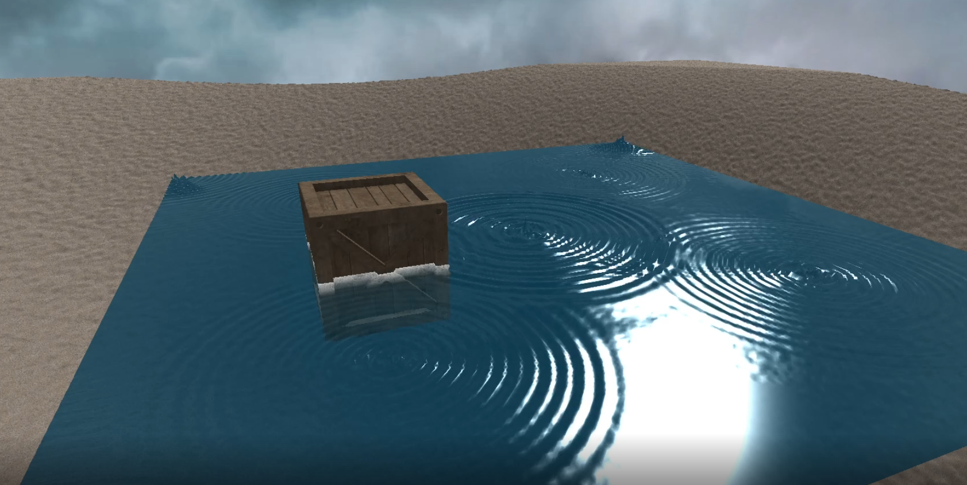

Figure : iWave in action. Ripples caused by sources and the crate is an obstruction.

### Water Objects

To create an object that will bob and shift with the flow of the water a few simple checks can be done. The first check that must be done is that of where the object is in relation to the simulation. Since the simulation can be tiled a quad tree like structure needs to be create. By creating this quad tree the offset to get the object back into the space of the original grid can quickly be determined. Once the object is back in the local space of the simulation grid, the vertices that are contained within the object can be determined. Since the grid is seamless if any part of the object is off of the grid the points that need to be sampled can come from the opposite side. As the points that are being contained are determined the heights and the normals at each one can be collected and averaged. Once all of the contained points have been processed a world transform matrix can be created using the normal average as the forward vector and the average height as a vertical offset. This matrix can then be applied to the local transform matrix of the object to create the bobbing effect.

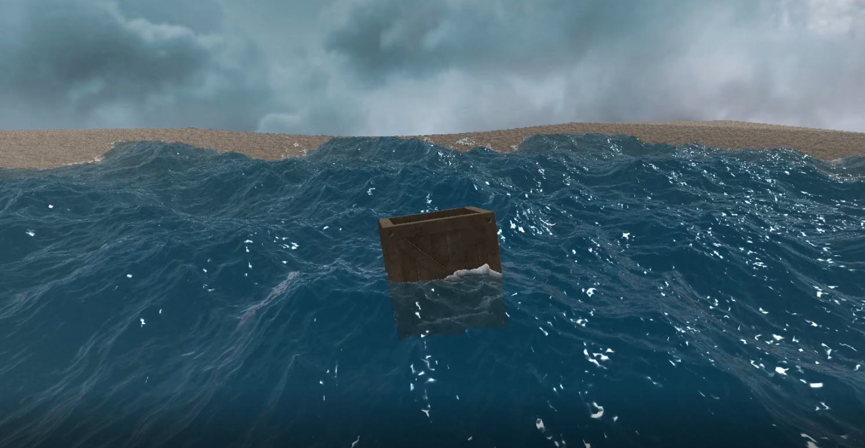

Figure : Bobbing water object

# Future Work

### Performance

The performance is not where it could be. Although FFT saw a huge spike in performance gains from DFT, there is still a ways to go to begin generating meshed with higher vertex density. The ways that this could be achieved is either through GPU Computation or threading. Both come with their unique set of problems. Where GPU Computation will be fast, a lot of the data that is need will have to be stored in images. For threading it is important to note that order matters when computing FFT in two dimensions.

Another potential point of interest for further performance improvements is looking into changing the vertex density of the mesh as it becomes further from the camera. Tessellation comes to mind when think about this functionality, but it also raises the concern that will the simulation still hold as it relies on manipulating vertices.

### iWave or eWave

One concern with the current implementation of iWave is that it is extremely computationally heavy. This layered on top of an already computationally heavy simulation in the FFT wave simulation leaves no room for other gameplay elements. While performance improvements can be achieved in the FFT simulation some improvements can also be made with iWave. While researching into iWave there was mention of a newer method called eWave. eWave utilizes an FFT form to be less computationally heavy and seamlessly incorporate itself into the larger FFT simulation.

### Aesthetics

While pursuing real-world level water graphics I stumbled across the issue that light’s interaction with water is quite complex. One light ray can have many different contact points with the water. Due to Snell’s law, the light ray can also bend out of the view frustum. With all these difficulties in having direction to sample but not necessarily the correct thing to sample in that direction this water simulation could greatly benefit from raytracing. This would solve the issue with accurate refraction sampling, the multiple light ray hits on the water’s surface, and make getting accurate reflection and transmission samples more comprehensive.

# Bibliography

|  |  |
| --- | --- |
| [1] | "Navier-Stokes Equations," Comsol, 22 February 2017. [Online]. Available: https://www.comsol.com/multiphysics/navier-stokes-equations. [Accessed 9 July 2020]. |
| [2] | J. Tessendorf, "Simulating Ocean Water," 2004. [Online]. Available: https://people.cs.clemson.edu/~jtessen/reports/papers_files/coursenotes2004.pdf. |
| [3] | J. Tessendorf, "Interactive Water Surfaces," 2004. [Online]. Available: https://people.cs.clemson.edu/~jtessen/reports/papers_files/Interactive_Water_Surfaces.pdf. |
| [4] | Scratchapixel, "Reflection, Refraction (Transmission) and Fresnel," scratchapixel, [Online]. Available: https://www.scratchapixel.com/lessons/3d-basic-rendering/introduction-to-shading/reflection-refraction-fresnel. [Accessed 5 May 2021]. |